Fundamental of Psychology
Myths about Psychology
- It’s all about reading faces and judging people
- Psychologist are magicians that can read mind and faces
- Psychiatrists are crazy people too
- Visiting psychiatrist means you are abnormal
What is Psychology:
- Derived from two Greek words
- Psyche means soul
- logos means to talk.
- literal meaning of Psychology is: to talk about soul.
Definition
Psychology is a science which deals with the behavior and minds of animals and human beings, both
Or branch of science focuses on two things
- Cognition (Mental Process)
- Not Solely related to abnormality (psychology is about understanding the human mind and behavior as a whole, not just focusing on mental illnesses)
Facts about Psychology:
- Psychology is a structured field of knowledge.
- It gathers and studies information.
- Psychologists help people live a balanced life.
- Anyone can see a psychologist, from simple counseling to treating major disorders
Behavior and Mind
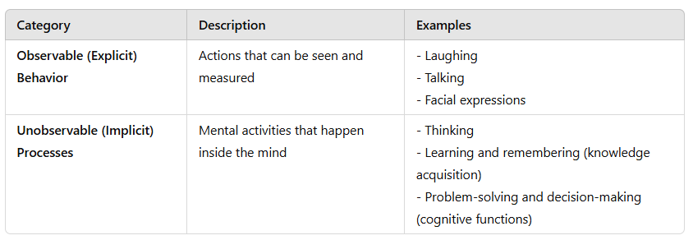
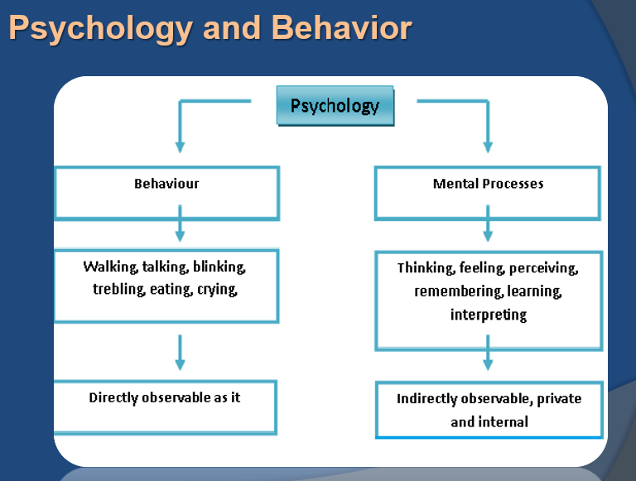

Understanding Behavior
Behavior refers to how people interact with others or themselves. Examples include:
- Talking to a friend
- Smiling when happy

Influence of Culture on Behavior
Culture plays a big role in shaping behavior. People from different cultures may express emotions in unique ways.
Example:
- In Western cultures, maintaining eye contact while talking shows confidence and respect.
- In some Asian cultures, avoiding eye contact can be a sign of respect, especially when speaking to elders.
Factors:
1. Literacy Rate & Living Standards
- A person’s education level and quality of life affect their behavior and communication.
- Higher literacy rates often lead to better decision-making and social interactions.
2. Social Interaction
- The way people connect and communicate with each other is shaped by their cultural background.
- Some cultures encourage open discussions, while others emphasize politeness and indirect communication.
3. Personal Space
- Cultural norms define personal space, which affects interactions.
- Example: In some cultures, maintaining a certain distance while talking is essential for respect, while in others, standing close shows warmth and friendliness.
4. Culture Shapes Behavior
- Culture influences personal growth, opportunities, and individuality.
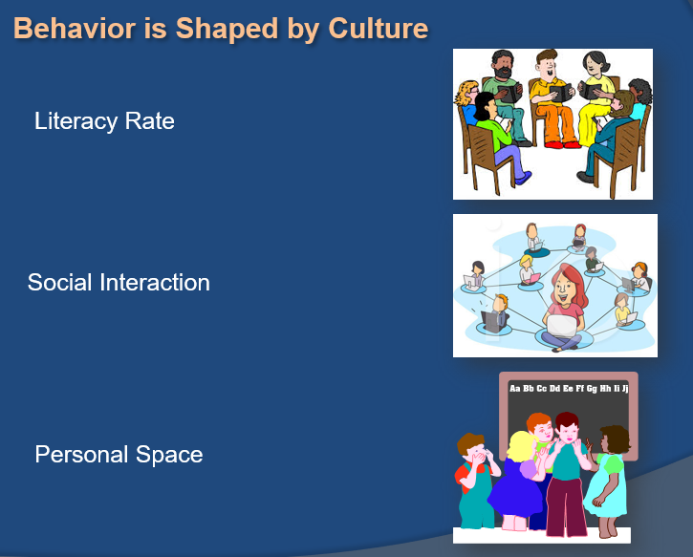
- The more open and diverse a culture is, the greater the chances for self-expression and personal development.
Psychology and Science/
- Psychology is Empirical → It is based on experiments and evidence.
- Knowledge is acquired through observation → Psychologists study behavior and mental processes by observing people.
- Systematic approach to understanding people → It helps in understanding thoughts, emotions, and behavior to solve real-life problems.
Example:
A psychologist observes that students with regular sleep perform better in exams. After research, they suggest a sleep schedule to improve learning.
Branches of Psychology:
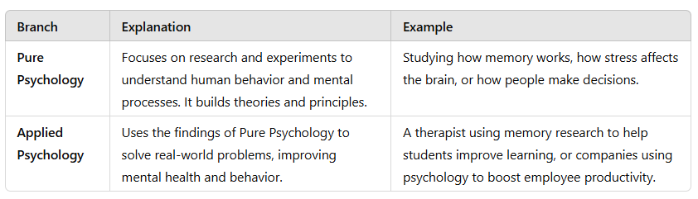
Pure Psychology:
Psychology is the study of how humans and animals behave and why they act in certain ways. It helps understand thoughts, emotions, and actions through research and data.
- Experimental Psychology focuses on studying behavior by collecting data and doing experiments.
- Social Psychology looks at how and why people behave in social situations.
- Abnormal Psychology studies unusual behaviors and mental health issues.
- Developmental Psychology explores how people grow and change over time.
- Comparative Psychology compares the behavior of different animals and humans.
- Physiological Psychology examines how the body reacts to emotions like happiness, stress, and mood changes.
Applied Psychology
Applied psychology uses psychological ideas to solve real-world problems in different areas like mental health, work, education, medicine, and law.
- Clinical Psychology helps people with mental and emotional health issues.
- Industrial Psychology studies how employees behave at work to improve productivity.
- Educational Psychology focuses on how people learn and remember things in school.
- Psychology in Medicine helps doctors use psychology to improve patients' physical and mental health.
- Psychology in Law studies how people understand legal rules and make decisions in court.
Four Primary Goal of Psychology:
Describing and Explaining Behavior
First goal, differentiating between normal, healthy and unhealthy behaviors is the cornerstone of psychology, so it is important that psychologists have a keen sense of observation.
The second goal of psychology, explaining. The attempt to explain behavior based on observation is actually rather difficult due to many factors. For instance, behavior varies among culture and can change over time.
Predicting and Influencing Behavior
Third goal, Psychologists try to determine if a person is likely to make healthy or unhealthy decisions when confronted with certain situations. Most of the time, they will use experiments to make their predictions.
The fourth and the last goals of psychology is to influence behavior. This can be to change unhealthy behavior as well as encourage already existing healthy behavior. There are many methods used to influence behavior such as positive reinforcement or rewarding good behavior.
Rewards (Tangible or External Benefits)
Money – Giving a bonus for hard work
Gifts – Giving a child a toy for good grades
Positive Reinforcement
Encouragement – Motivating someone with kind words
Recognition – Awarding certificates or trophies for achievements
Biological Psychology:
Biological psychology studies how the brain and body influence emotions, memories, and sensory experiences. It includes psychology, biology, physiology, biochemistry, and neuroscience.
- Biological psychology studies the connection between biology and psychological events, like how information moves through the body.
- It also examines body functions, including electrical and chemical processes needed for nervous system communication.
Note: A psychological event refers to any mental or emotional experience influenced by the brain and body. This includes thoughts, emotions, perceptions, and behaviors.
Examples:
- Feeling fear when you see a dangerous animal.
- Remembering a happy memory from childhood.
Behavioral Psychology:
Behavioral Psychology is the study of how people act and react. Behavior means actions we take in response to something. This type of psychology focuses only on actions we can see, not thoughts or feelings.
- Example: Child and Rewards – A child who gets praised for doing homework is more likely to do it again.

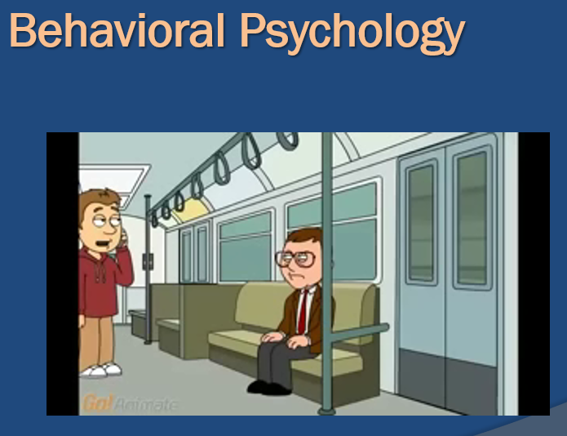
Cognitive psychology
Cognitive psychology is the study of how people think, learn, remember, and solve problems. It focuses on mental processes like attention, memory, perception, decision-making, and language.
- Example: Memory Recall – Remembering your friend's birthday or recalling the name of a song.
Social-Cultural Psychology
Social-Cultural Psychology is about how people are influenced by society and culture. It looks at how our behavior, thoughts, and feelings are shaped by the people around us and the traditions we follow.
For example:
- A person raised in a community that values teamwork may prioritize group success over personal achievements.
- People from different cultures may express emotions differently, such as being more reserved or more expressive.
This also focuses on the fact that our interactions with others in society affect not only our thought process, but also our perception, and the manner in which we make decisions.
Example:
From childhood, we learn from our surroundings, and as we grow older, these influences become even stronger.
Personality Psychology
Personality psychology is a branch of psychology that studies personality and individual differences—what makes us unique.
Key Points:
- It focuses on how our interactions with others shape our thoughts, perceptions, and decision-making.
- Personality development starts in childhood and continues throughout life.
- It explores how personality forms, evolves, and influences behavior.
Experimental Psychology:
Experimental Psychology: A way of studying how the mind works using scientific methods. It helps researchers understand thoughts, feelings, and behaviors through experiments.
- Example: - A memory experiment where researchers show a list of words to participants and then test how many they can remember. This helps understand how memory works and what factors improve or weaken it.
Educational Psychology
Educational Psychology is the study of how people learn in schools. It looks at how teaching methods, school environments, and social interactions affect learning. It also explores how children and teenagers think, feel, and grow as they learn.
- Example: A teacher notices that some students learn better with visual aids, while others prefer hands-on activities. Using educational psychology, the teacher adjusts their teaching style to include pictures, videos, and interactive activities to help all students learn effectively.
Industrial Psychology
It studies how employees and employers think and behave at work. It focuses on workplace environment, employee attitudes, and how these factors affect job performance and satisfaction.
- Example: - A company sees that workers are feeling tired and not working well. An industrial psychologist looks at the workplace, listens to employees, and suggests simple changes like better break times or a nicer office setup to make everyone happier and more productive.
Criminal Psychology:
Criminal psychology is the study of why people commit crimes. It looks at their thoughts, feelings, and actions that lead to criminal behavior.
- Example: - A criminal psychologist studies a thief’s past to understand why they steal. They may find that the person had a tough childhood or was influenced by bad company. This helps in finding ways to prevent future crimes.
Computational Psychology:
Computational psychology combines artificial intelligence and psychology to study how the human mind works using computer models. It helps in understanding thinking, decision-making, and behavior through simulations and algorithms.
- Example: A computational psychologist might create a computer model to predict how people make choices when shopping online.
Importance of Psychology
- Self-Knowledge: Learning is an important part of life, and understanding ourselves is a key part of that learning.
- Learning About Others: Psychology not only helps us understand ourselves but also helps us learn about other people.
- Solving Important Problems: Psychological theories and research can help us find solutions to real-life problems.
Development of Psychology
Human Development is the process of growing and changing throughout life, from birth to old age.
- It studies how and why people change over time.
- It includes physical growth, emotions, thinking abilities, social skills, and personality.
- Example: A baby learning to walk, a child developing friendships, or an adult gaining new skills at work.
Research Method in Psychology
What is Research Method?
A systematic plan to conduct research is called a research methodology.
Types:
- Descriptive Research Method
- Correlational Research Method
- Experimental Psychology
Descriptive Research Method:
This method is used to describe a situation, behavior, or characteristic without changing or influencing anything. We simply further trying to explore and already existing phenomenon.
Example
A researcher asks college students about their sleep habits and records the answers without changing anything. This helps understand sleep patterns.
Methods
- Observational Research/Naturalistic
- Surveys
- Case Studies

Observational Research Method
It means watching and listening to how people behave in a place like a classroom or lab without asking questions or changing anything. It only records what happens without explaining why.
Types:
There are two types of observational research method
- Observation without intervention
- Observation with intervention
Observation without intervention/ Naturalistic
This means watching people or events in their natural setting without interfering. The observer does not change anything, just takes notes or uses audio/video recording.
- Example: Watching kids play in a park from a distance or observing how people behave at work without interrupting.
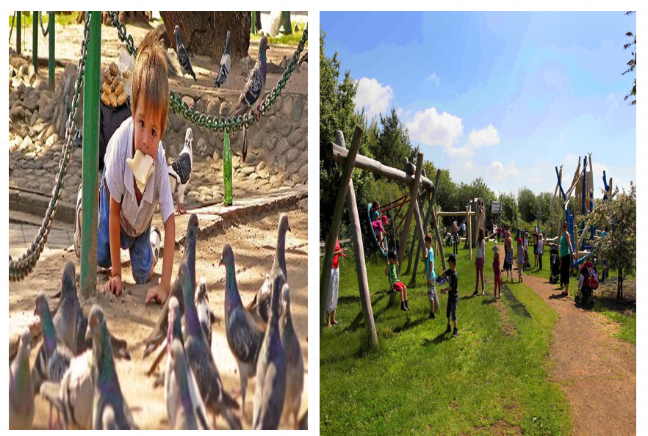
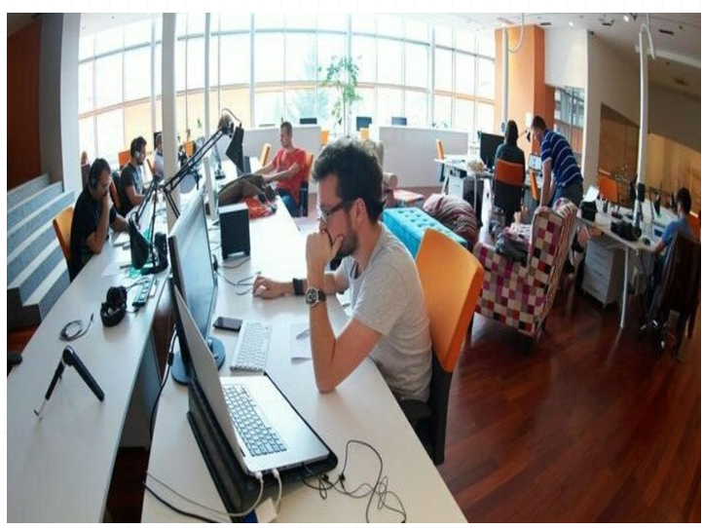
Observation with intervention
Observation with intervention (Participant Observation) means the researcher joins the group and takes part in activities while observing people.
- Example: A teacher joins students in a classroom to observe their behavior while also teaching.
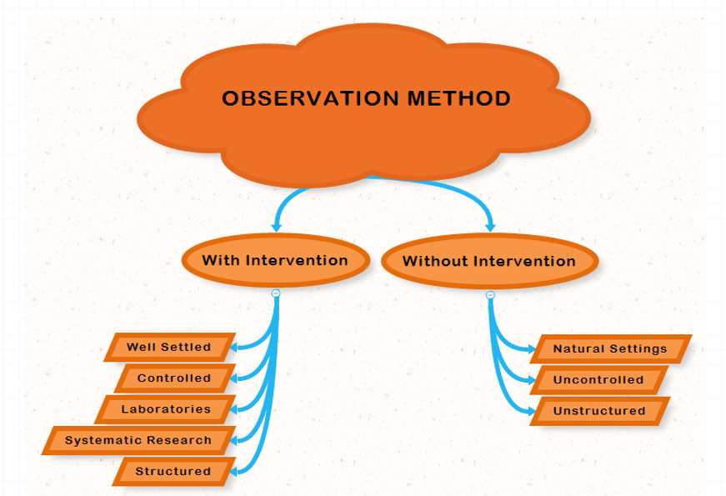
Survey Method:
A method where a sample of people represents a larger population and answers questions about their behavior, thoughts, or attitudes.
Use Cases
- When quick information is needed (e.g., opinion polls).
- When data is needed from a large population (e.g., population census).
Surveys are more suitable when goals of study are to find out about public opinion, attitude, likes/dislikes

Sources
- Questionnaires
- Interviews
- Online
- Telephonic
Components
- Population: The people who are the focus of research
- Sample: A part of population that represents the whole
- Questionnaires – A set of written questions given to subjects to collect data.
- Interviews – A face-to-face or verbal questioning process conducted by a researcher.
Case Study
- An in-depth intensive investigation of an individual or small group of people
- Researcher talks to participants in order to learn about their opinions, attitudes, preferences, likes, dislikes to find out the causes
- Used as a source of data collection in surveys but also used otherwise as well
Correlational Method
This method is used to find a relationship between two things but does not prove that one causes the other. It only shows if they are connected.

Example
The more time students spend studying, the higher their grades tend to be. However, studying does not guarantee higher grades, as other factors like sleep and teaching quality also play a role
Types
- Positive correlation
- Negative correlation
- Zero correlation
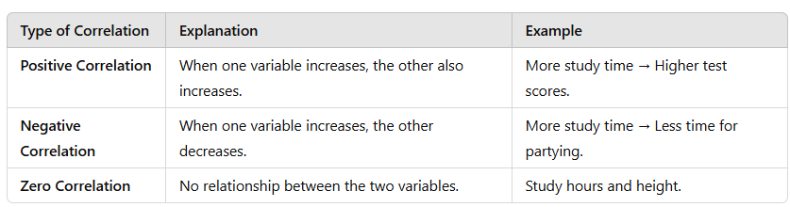
Experimental Research Method:
This method is used to find out if one thing causes another by changing one factor (independent variable) and measuring its effect on another (dependent variable). It includes a control group (which gets no change) and an experimental group (which gets change).
Components
- Experiment
- Control
- Variables
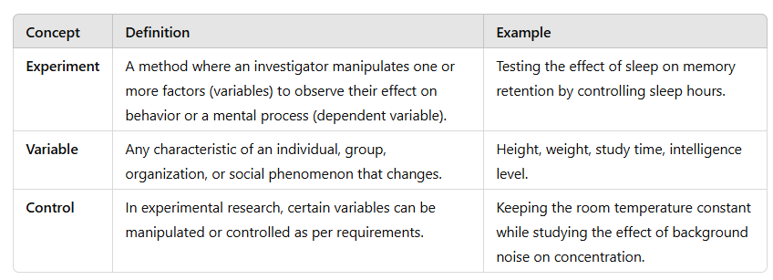
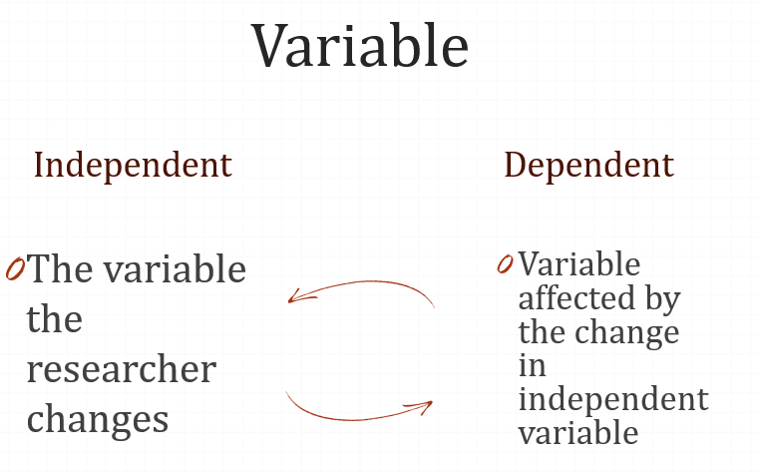

Learning
Learning is often defined as a relatively lasting change in behavior that is the result of experience. learning is the most hopeful of the fields of psychology.
Example:
A child touches a hot stove and gets burned. After that, they avoid touching hot objects. This change in behavior (avoiding heat) is due to learning from experience.
Behaviorism
Behaviorism, founded by John B. Watson, is a school of psychology that focuses only on actions that can be observed and measured. It does not study thoughts or emotions because they are internal and cannot be seen. Instead, behaviorism looks at how people act and respond to different situations.
Example:
For example, if a student studies hard and gets good grades, behaviorists would focus on the study habits rather than the student's thoughts or feelings.
Types of Learning
- Classical Conditioning
- Operant Conditioning
- Cognitive Learning
- Observational Learning

Neutral Stimulus
A stimulus that, before conditioning, does not trigger any specific response.
Example:
A bell ringing before being associated with food does not cause salivation in a dog.
Unconditioned Stimulus
A stimulus that naturally triggers a response without any prior learning.
Example
The smell of food naturally causes a dog to salivate.
Unconditioned Response
A natural and automatic reaction that occurs in response to an unconditioned stimulus without the need for learning.
Example
Salivating when smelling food is a natural response.
Key difference: Unconditioned Stimulus causes the reaction, while Unconditioned Response is the reaction.
Conditioned Stimulus (CS)
A previously neutral stimulus that, after being repeatedly paired with an unconditioned stimulus, starts triggering a response.
Example
After repeated pairing with food, the sound of a bell alone causes the dog to salivate.
Conditioned Response (CR)
A learned response that occurs when a previously neutral stimulus (NS) becomes associated with an unconditioned stimulus (US).
Example
A dog salivates when hearing a bell, even if no food is present. Initially, the bell was neutral, but after being repeatedly paired with food, the dog learned to associate it with food. Now, the bell alone causes salivation, making it a conditioned response.
Classical Conditioning
Classical conditioning is a type of learning where a person or animal starts reacting to something new because it gets linked to something they already react to.
Example:
At first, a bell (neutral stimulus) means nothing to a dog. But if you ring the bell every time before feeding the dog, the dog will start linking the bell to food. Eventually, the dog will salivate just by hearing the bell, even if there is no food.
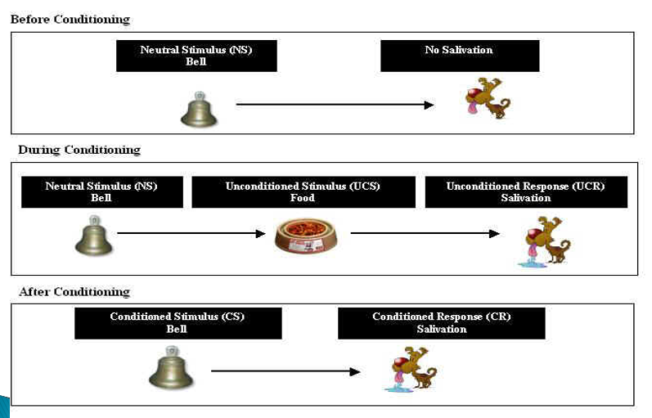
Example In real life
For Example - "fear of bridges “....
A person may develop a fear of bridges through classical conditioning like this:
- Unconditioned Stimulus (US) → A scary experience (e.g., getting stuck on a high bridge during a storm).
- Unconditioned Response (UR) → Feeling terrified during that experience.
- Neutral Stimulus (NS) → The bridge itself (before the scary event, the bridge was neutral).
- Conditioning Process → The person now associates the fear they felt with bridges in general.
- Conditioned Stimulus (CS) → Now, just seeing a bridge or thinking about crossing one triggers fear.
- Conditioned Response (CR) → The person feels anxious or scared whenever they approach a bridge.
Operant Conditioning
Operant conditioning is a way of learning where behaviors are shaped by rewards or punishments. If an action leads to a good outcome, it is more likely to be repeated. If it leads to a bad outcome, it is less likely to happen again. In this learning we are a sought of conditioned base on consequences.
Example:
- If a child gets candy for doing homework, they are more likely to do it again (reward).
- If a child is scolded for shouting, they are less likely to shout again (punishment).
Skinner Experiment
Skinner wanted to study how animals learn in a controlled environment. He created the "Skinner Box," a special chamber with a lever and a food dispenser.
In his experiment, a hungry rat was placed in the box. At first, the rat moved around randomly. By chance, it pressed the lever, and food appeared. The rat did not immediately understand the connection, but after pressing the lever multiple times, it learned that pressing the lever leads to food.
Skinner measured learning by counting how many times the rat pressed the lever within a certain time. This is called the "rate of response."
Skinner’s experiment is an example of operant learning because the rat’s behavior (pressing the lever) is shaped by its consequences (getting food).
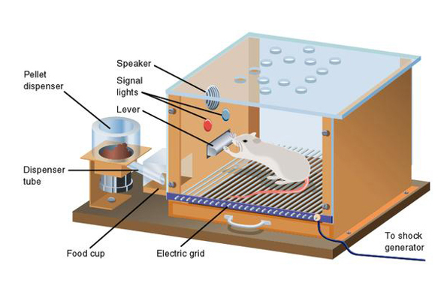
Cognitive Learning
Cognitive learning is how we learn by thinking and understanding. It happens when we gain knowledge through listening, watching, touching, or experiencing things around us.
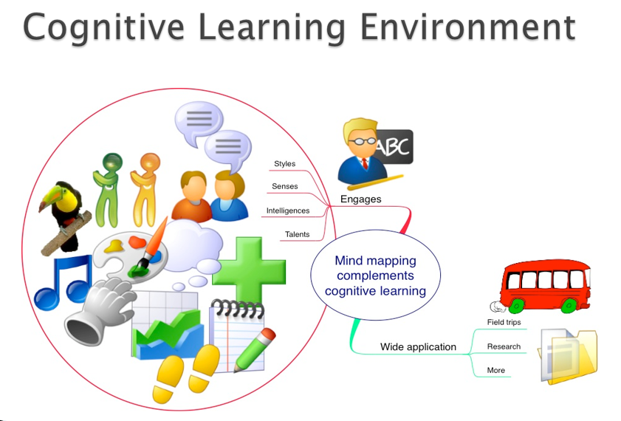
Continue…
Cognitive learning is a strong way of gaining knowledge. It’s more than just copying others—it involves thinking, understanding, and processing information in our minds. It helps us create mental images of objects and events and allows us to organize and use information in different ways.
Real life Example:
A real-life example of cognitive learning is learning to drive a car. At first, a learner doesn’t just memorize steps—they observe how others drive, understand traffic rules, and mentally process how to control the vehicle. With practice, they develop problem-solving skills, like deciding when to brake or change lanes, making driving an automatic and efficient process over time.
Latent Learning (Hidden Learning)
Latent learning happens when we learn something but don’t show it right away. It only becomes useful when we need it.
Example
A student walks around campus daily but never thinks about nearby coffee shops. One day, they want coffee and suddenly remember a new shop they had seen before.
E.C. Tolman’s Idea: He believed that people and animals create mental maps of their surroundings, which they use when needed.
Observational Learning (Learning by Watching)
First introduced by Albert Bandura, observational learning happens when we learn new behaviors by watching and copying others. It is also called vicarious learning, modeling, or social learning.
Example
Example of observational learning is when a teenager learns how to cook by watching their parents in the kitchen. They observe the steps, remember them, and later try cooking the same dish themselves.
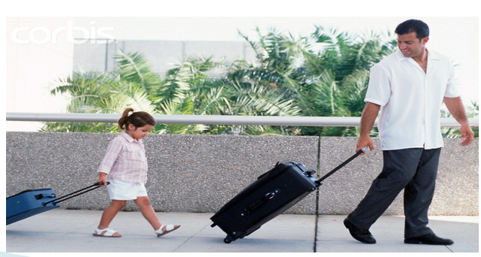
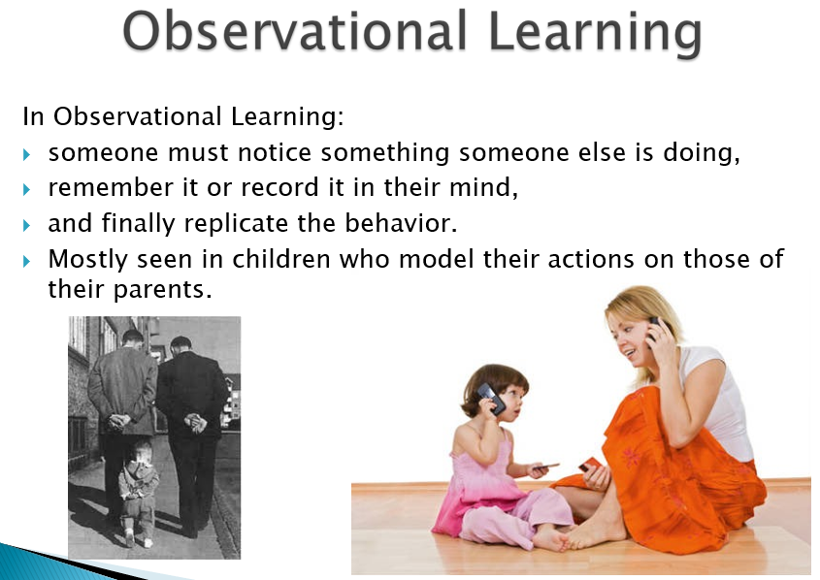
Observational Learning (Modeling) - Simple Explanation
Observational learning is limited by:
- Intelligence level – The smarter a person is, the better they learn by watching.
- Ability to copy – Some people can imitate actions better than others.
This type of learning is also called modeling, which has two main parts:
- Observation – Watching someone do an action.
- Imitation – Trying to copy that action.
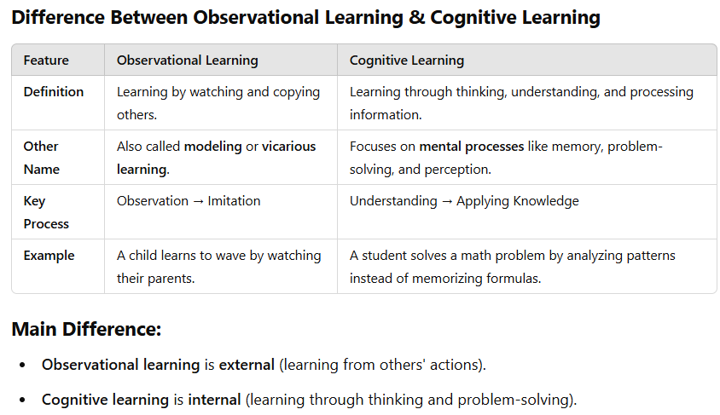
The Modeling Process
- Attention – You must focus on what the person is doing to learn from them. Distractions can make learning harder.
- Retention – You need to remember what you observed so you can use it later.
- Reproduction – After watching and remembering, you try to copy the behavior.
- Motivation – You need a reason to imitate the behavior. If there’s no interest or reward, you might not copy it.
Example: A child watches their older sibling ride a bicycle (Attention), remembers how they balance (Retention), tries to ride on their own (Reproduction), and keeps practicing because they want to have fun (Motivation).
Bobo Doll Experiment (Bandura's Study on Observational Learning)
Albert Bandura conducted an experiment to show how children learn through observation and imitation.
What Happened?
- Watching the Model – Children watched a video of a man aggressively attacking a Bobo doll (a large plastic clown). He hit it, punched it, kicked it, and threw things at it.
- Frustration – After watching the video, the children were placed in a room with attractive toys but were not allowed to touch them, which made them frustrated.
- Imitation – They were then taken to another room with Bobo dolls and the same toys from the video. Many children copied the aggressive behavior they had seen, hitting and kicking the doll just like the man in the video.
Conclusion:
This experiment showed that children learn and imitate behaviors just by watching others, proving the power of observational learning and modeling.
